DOC-GENIE

Project Description
Doc-Genie is an intelligent Python documentation generation tool designed to automatically create professional docstrings for Python functions. In software development, writing proper documentation is very important for understanding and maintaining code. However, developers often spend a lot of time manually writing documentation. Doc-Genie solves this problem by automatically analyzing Python functions and generating clear and structured docstrings using advanced code analysis techniques.
The system uses Python’s Abstract Syntax Tree (AST) module to analyze the structure of the source code. By parsing the function definition, Doc-Genie can extract important details such as the function name, parameters, default values, return types, and logical operations used inside the function. Based on this information, the tool generates documentation in standard formats such as Google-style and NumPy-style docstrings, which are widely used in professional Python development.
The project also includes an interactive user interface built using the Gradio framework, allowing users to easily input Python code or upload Python files and instantly generate documentation. Additionally, the tool provides export options such as PDF and TXT reports, making it useful for documentation sharing and project reporting. Overall, Doc-Genie helps developers, students, and teams improve code readability, maintain consistent documentation standards, and reduce the effort required for manual documentation writing.

Scenarios

Scenario 1: Legacy Code Documentation
In many software projects, developers often work with old codebases that do not have proper documentation. Understanding such code can be very difficult and time-consuming. With the help of Doc-Genie, developers can quickly generate documentation for all functions in the code. The system analyzes the function structure using AST and automatically generates clear docstrings. This helps developers understand the code easily and improves maintainability.

Scenario 2: API Development and Documentation
When developers build APIs or backend services, they must maintain proper documentation for each function or endpoint. Writing documentation manually for every function can slow down development. Doc-Genie helps developers by automatically generating docstrings for newly created functions. By analyzing parameters, return types, and logic inside the function, the tool produces accurate documentation that follows standard formats like Google or NumPy style.

Scenario 3: Team Collaboration and Code Standards
In software development teams, multiple developers work on the same project. Maintaining consistent documentation style across the project is very important. Doc-Genie ensures that all functions follow a standard documentation format. Team members can generate documentation for their functions and export reports in PDF or text format. This helps the team maintain consistent coding standards and makes code reviews easier.

Scenario 4: Educational and Learning Purpose
Doc-Genie can also be used as a learning tool for students who are studying Python programming. Beginners often struggle to understand how to write proper docstrings and documentation. By using this tool, students can see automatically generated docstrings for their functions and learn the correct documentation style. This helps them understand best practices in coding and improves their programming skills.

Scenario 5: Code Review and Quality Assurance
In software development, code review is an important process to ensure that the code meets quality standards. One of the key aspects checked during code review is whether functions are properly documented. With the help of Doc-Genie, reviewers can quickly generate docstrings for functions and compare them with the existing documentation. This helps identify missing or incomplete documentation. As a result, the development team can maintain better code quality and ensure that all functions are properly documented before the code is deployed.

Architecture Overview
The Doc-Genie system is designed using a modular architecture that combines Python’s AST (Abstract Syntax Tree) analysis with an interactive user interface built using the Gradio framework. The architecture focuses on analyzing Python code efficiently and generating accurate documentation automatically. Each module of the system performs a specific function such as code input, function analysis, docstring generation, and exporting results. This modular design makes the system easy to understand, maintain, and extend with additional features in the future.
The architecture begins with the code input module where users can either type Python code or upload a Python file. The system then uses the AST module to parse the code and extract important information such as function names, parameters, default values, and return types. After analyzing the function logic, the docstring generation module creates documentation in standard formats like Google style or NumPy style. Finally, the generated documentation is displayed through the Gradio interface and can be exported as PDF or TXT files. This architecture ensures efficient code analysis and provides a user-friendly experience for developers and students.

Core Technologies
· Python 3.8+: Core language with AST module for code analysis
· Gradio 4.0+: Interactive web interface framework
· AST (Abstract Syntax Tree): Python's built-in code parsing library
· ReportLab: PDF generation for comprehensive documentation reports
· Regular Expressions: Pattern matching for code analysis
· Google Colab: Cloud-based development and deployment environment
· HTML5/CSS3: Modern web standards for interface styling

Pre-requisites
Before running the Doc-Genie project, certain software, knowledge, and hardware requirements must be fulfilled. These requirements ensure that the system can run smoothly and the user can effectively use the application.

Software Requirements
The following software components are required to run the project:
• Python 3.8 or higher – The main programming language used to build the system. It includes built-in libraries such as AST which are required for code analysis.
• Google Account – A Google account is required to access Google Colab for running the project in a cloud environment.
• pip (Python Package Manager) – pip is used to install the necessary Python libraries required for the project. It usually comes pre-installed with Python.
• Web Browser – A modern web browser such as Google Chrome, Mozilla Firefox, Microsoft Edge, or Safari is required to access the Gradio interface.
• Internet Connection – Internet access is necessary when using Google Colab and for sharing the Gradio interface.

Knowledge Prerequisites
To understand and use the system effectively, the user should have basic knowledge in the following areas:
• Python Programming Fundamentals – Basic understanding of Python functions, parameters, and return values.
• Python AST (Abstract Syntax Tree) – Basic idea of how Python code can be parsed and analyzed using AST.
• Python Docstrings – Familiarity with documentation styles such as Google style and NumPy style docstrings.
• Gradio Framework – Basic knowledge of how Gradio is used to create interactive web interfaces.
• Code Analysis Concepts – Understanding of how programs analyze code structures to extract information.
• Google Colab Environment – Basic understanding of how to run and execute code cells in Google Colab.

Hardware Requirements
The following hardware specifications are recommended for running the project:
• Processor – Any modern processor such as Intel i3 or equivalent.
• RAM – Minimum of 2GB RAM is required for running the application locally. Google Colab provides cloud resources if local resources are limited.
• Storage – At least 500MB of free storage space is required to store project files and generated PDF documents.
• Display – A display with minimum resolution of 1024 × 768 for comfortable viewing of the interface.

Project Workflow

Phase 1: Environment Setup & Core Architecture

Activity 1.1: Install Dependencies and Configure Environment
In the first step of the project, the required software environment is prepared. A requirements file is created to include all the necessary libraries required for the system. These libraries include Gradio for building the interface, ReportLab for generating PDF reports, and other Python packages used for code analysis.
The project is executed using the Google Colab platform, which provides a cloud-based environment for running Python applications. All required packages are installed using the pip package manager. After installation, the environment is tested to ensure that all libraries are correctly installed and that the Python AST module is available for code analysis.

Activity 1.2: Design DocGenieAnalyzer Core Class
The next step is designing the core analysis component of the system called the DocGenieAnalyzer class. This class is responsible for analyzing Python functions and generating documentation.
The class contains methods for extracting function signatures, analyzing the logic inside functions, and generating docstrings in different formats. The system also maintains a history of generated documentation so that users can review previous results if needed.

Phase 2: Advanced Code Analysis Engine

Activity 2.1: Implement Function Signature Extraction
In this stage, the system extracts detailed information about Python functions using AST parsing. The function signature extraction module identifies the function name, parameter names, parameter types, default values, and return type annotations.
By analyzing the structure of the function definition, the system collects all necessary information required for generating proper documentation.

Activity 2.2: Build Deep Logic Analysis System
After extracting the function signature, the system performs deeper analysis of the function logic. This is done by walking through the AST nodes of the function body.
The analysis module detects programming constructs such as loops, conditional statements, mathematical operations, return statements, and function calls. Based on this analysis, the system generates a contextual description explaining what the function does.

Phase 3: Interface Development & User Experience

Activity 3.1: Build Main Code Input and Output Interface
In this phase, a user-friendly interface is created using the Gradio framework. The interface allows users to enter Python code in a text area or upload Python files directly.
The interface also includes a style selection option where users can choose between Google-style or NumPy-style docstrings. After the user clicks the generate button, the system processes the code and displays the function with the generated docstring.

Activity 3.2: Implement Export Functionality
The system also provides export options so that the generated documentation can be saved and shared. Users can export the documentation as a PDF file or a TXT file.
The export module ensures that the documentation is properly formatted and includes relevant metadata such as timestamps and analysis details.

Phase 4: Export & Reporting System

Activity 4.1: Implement PDF Report Generation
In this stage, the ReportLab library is used to generate professional PDF reports. The PDF includes formatted code blocks, generated docstrings, and additional details such as the date and time of generation.
This allows users to download and share documentation reports easily.

Activity 4.2: Implement Text File Export
The system also supports exporting documentation as a plain text file. The text file contains the original code along with the generated documentation. Clear separators are used to improve readability and ensure that the output is well organized.

Technical Architecture:
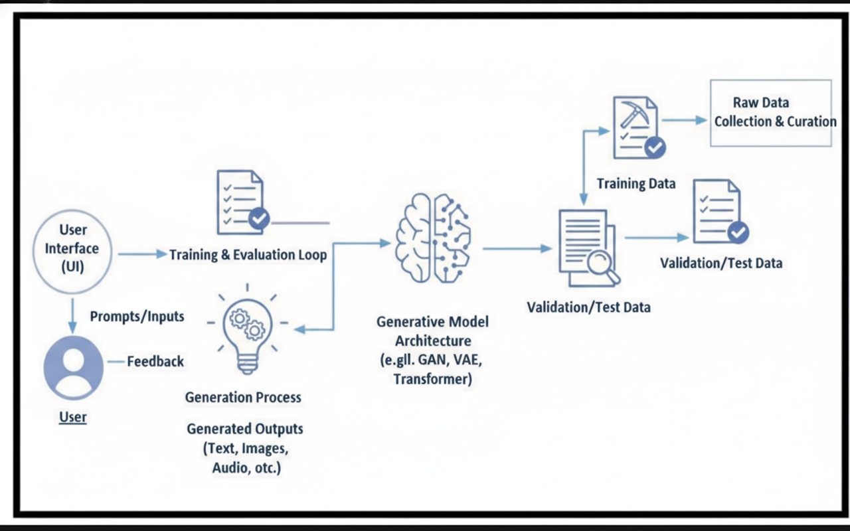

Project Structure:
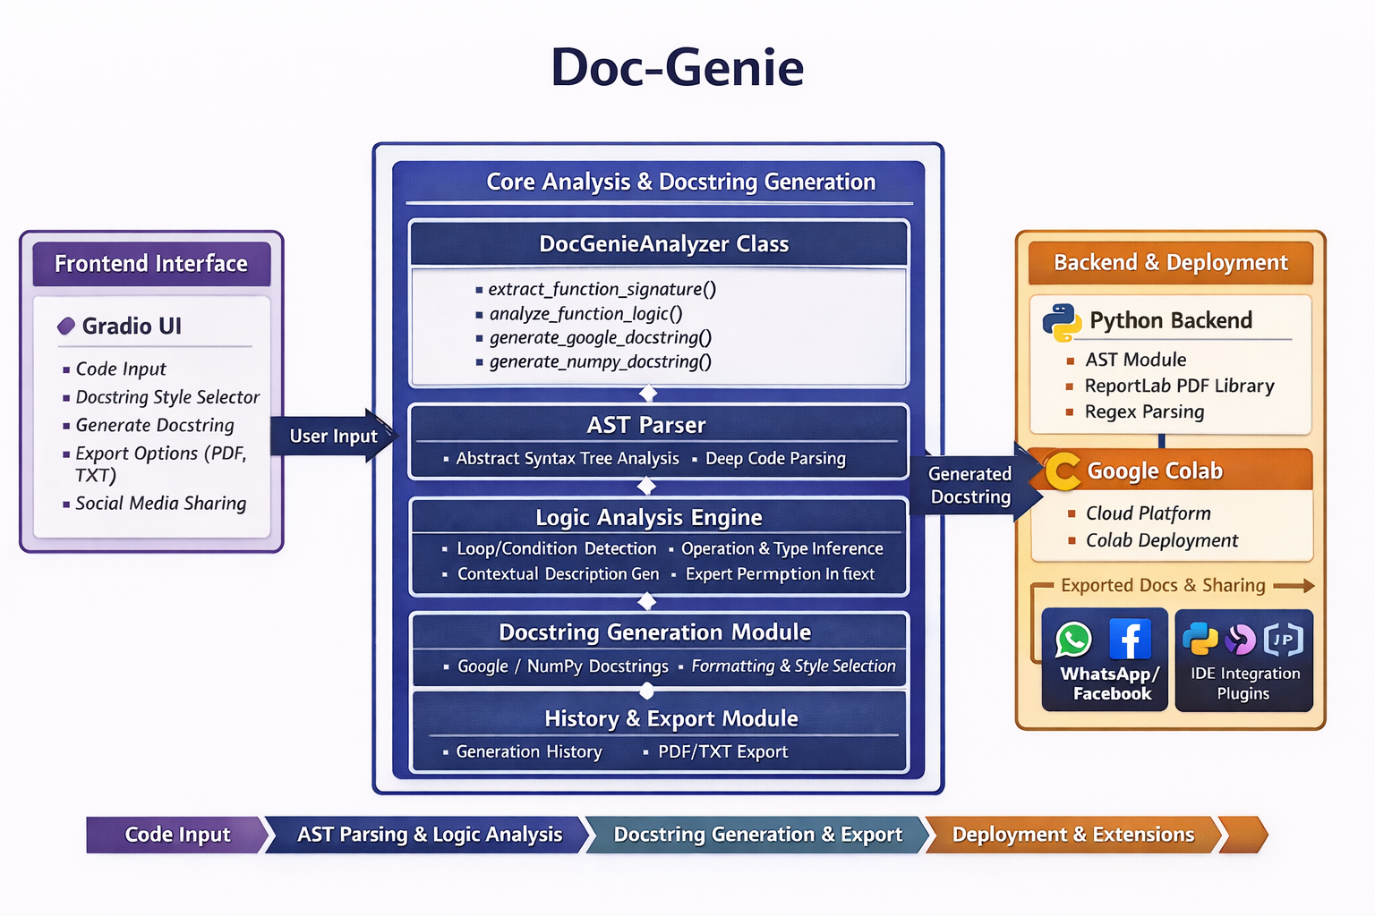
MILESTONE 1: Environment Setup & Core Architecture

Activity 1.1: Install Dependencies
In the first milestone, the required dependencies for the project are installed. A requirements.txt file is created which contains all the necessary libraries required for running the application. These libraries support the interface creation, code analysis, and documentation export features of the system.
The following dependencies are used in the project:
• gradio – Used for building the interactive web interface.
• transformers – Used for advanced code understanding.
• torch – Supports machine learning based processing.
• reportlab – Used to generate PDF documentation reports.
• requests – Helps in handling network requests if needed.
• black – Used for formatting Python code.
• autopep8 – Helps in automatically fixing Python code style.
These dependencies can be installed using the following command:
pip install -r requirements.txt
After installation, the environment is verified to ensure all packages are installed successfully and the Python AST module is functioning properly.
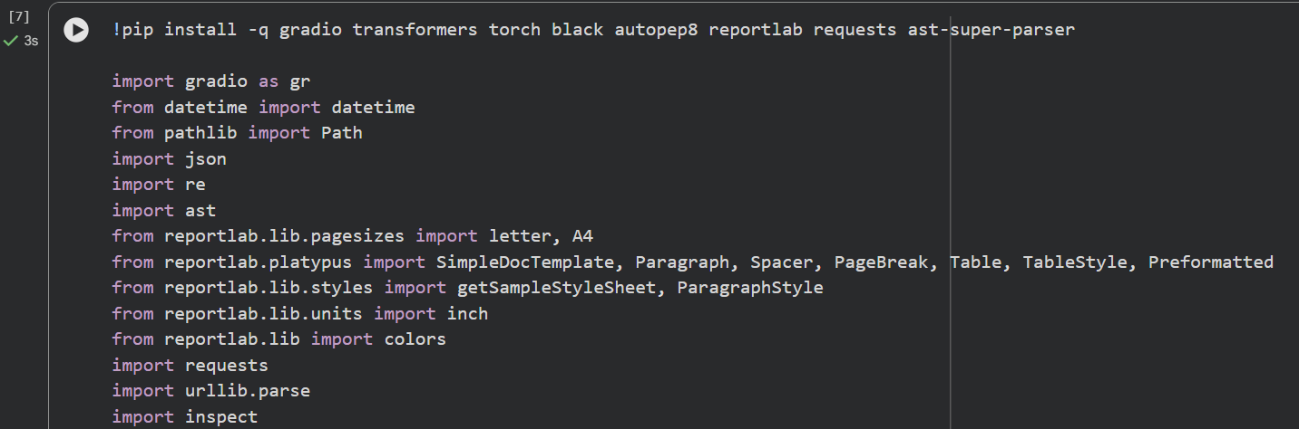 Code reference

Activity 1.2: Initialize Core Analyzer Class
Create DocGenieAnalyzer class with following structure:
class DocGenieAnalyzer:
@staticmethod
def extract_function_signature(code):
- Parse AST from code
- Extract function name, parameters, return type
- Return signature dictionary
@staticmethod
def analyze_function_logic(func_def, code):
- Walk through AST nodes
- Detect loops, conditions, operations
- Generate contextual description
- Return analysis dictionary

@staticmethod
def generate_google_docstring(signature, analysis, code):
- Format Google-style docstring
- Include summary, args, returns
- Return formatted string
@staticmethod
def generate_numpy_docstring(signature, analysis, code):
- Format NumPy-style docstring
- Include summary, parameters, returns
- Return formatted string

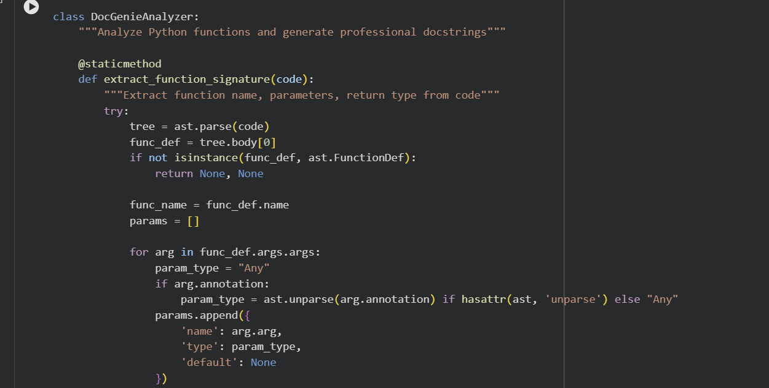
Code reference

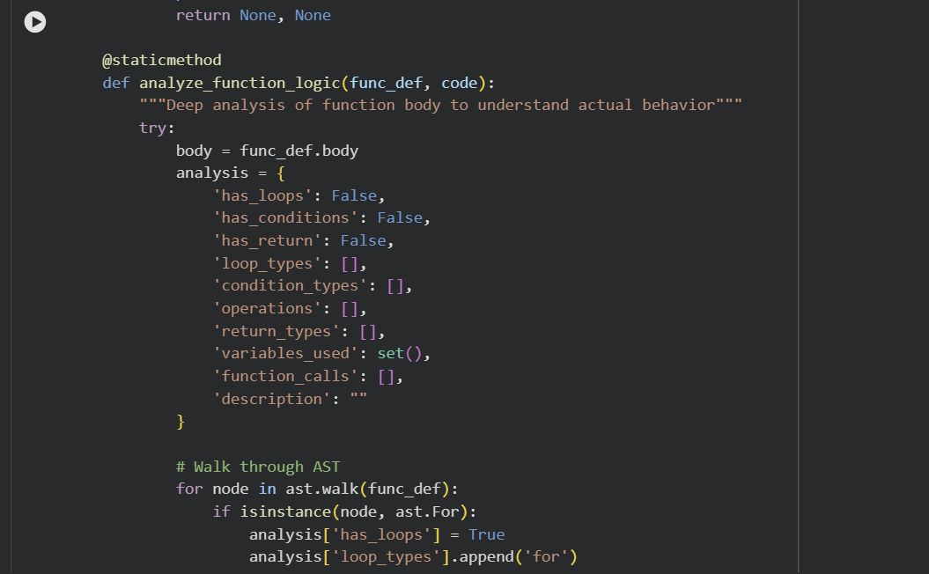
Code reference

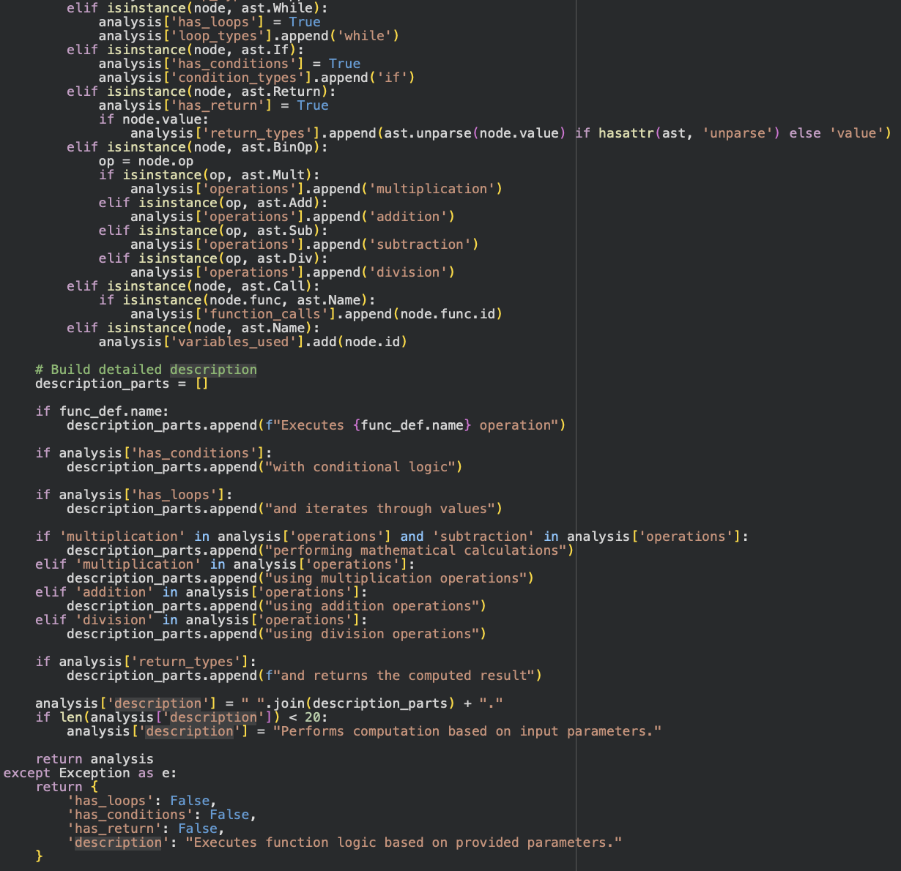
Code reference

MILESTONE 2: Advanced AST Analysis Engine

Activity 2.1: Function Signature Extraction
In this stage, the system extracts important details about Python functions using the Abstract Syntax Tree (AST) module. The AST module converts the Python source code into a structured tree format, which allows the system to analyze different parts of the code effectively.
The function signature extraction process identifies key components of the function such as the function name, parameters, parameter types, default parameter values, and return type annotations. This information is necessary for generating accurate documentation.
For example, consider the following Python function:
def calculate(x: int, y: float = 3.5) -> float:
return x * y
The system extracts the following information:
{
'name': 'calculate',
'params': [
{'name': 'x', 'type': 'int', 'default': None},
{'name': 'y', 'type': 'float', 'default': '3.5'}
],
'return_type': 'float'
}
This extracted information is stored in a structured format so it can be used later for documentation generation.

Activity 2.2: Deep Logic Analysis
After extracting the function signature, the next step is analyzing the internal logic of the function. This process is performed by traversing the AST nodes within the function body.
The logic analysis module detects different programming constructs such as:
• Loop Detection – Identifies for loops and while loops.
• Condition Detection – Detects if, elif, and else statements.
• Operation Detection – Recognizes mathematical operations such as addition, subtraction, multiplication, and division.
• Return Analysis – Tracks return statements and identifies the type of value returned by the function.
• Function Calls – Detects calls to other functions inside the code.
• Variable Usage – Tracks variables used in the function.
The output of this analysis helps generate a meaningful description of the function behavior, which is incluMILESTONE 3: Docstring Generation & Formatting

Activity 3.1: Google-Style Docstring Generation
In this phase, the system generates documentation using the Google-style docstring format, which is commonly used in professional Python projects. The generated docstring includes a short summary of the function, a description of parameters, and information about the return value.
Example generated docstring:
"""
Calculate factorial of a number.

Executes calculation with conditional logic and returns
the computed result.

Args:
n (int): Parameter for controlling n behavior.

Returns:
int: The result of the computation.
"""
This format improves readability and helps developers quickly understand the purpose of the function.

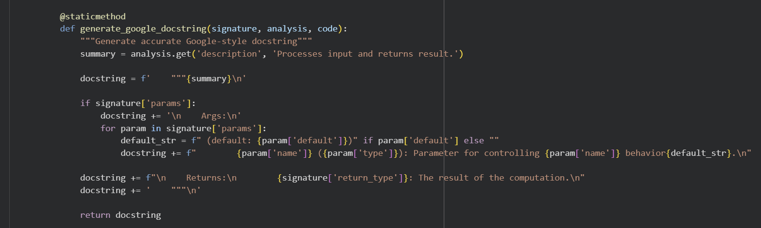Code reference

Activity 3.2: NumPy-Style Docstring Generation
The system also supports NumPy-style docstrings, which are widely used in scientific and data science applications. This format organizes the documentation into sections such as parameters and return values.
Example NumPy-style docstring:
"""
Calculate factorial of a number.

Executes calculation with conditional logic and returns
the computed result.

Parameters
----------
n : int
Parameter for controlling n behavior.

Returns
-------
int
The result of the computation.
"""
By providing multiple documentation styles, the system allows developers to choose the format that best suits their project requirements.
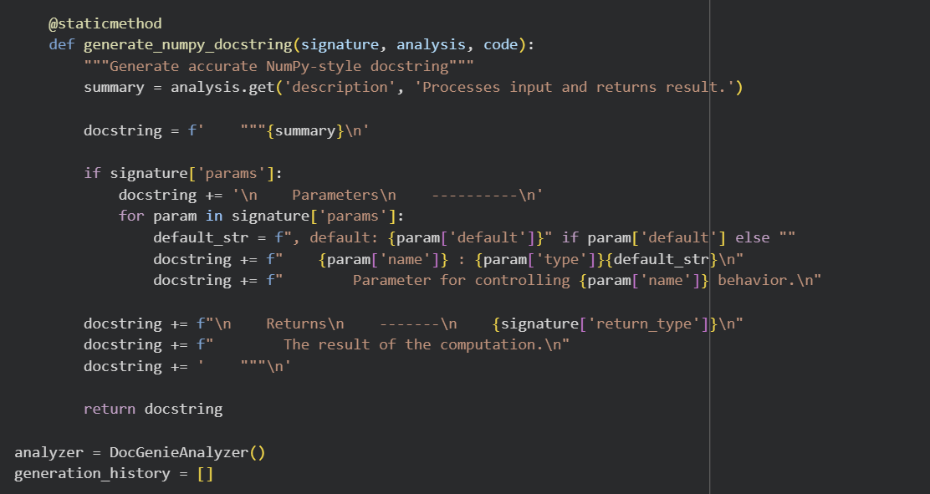 Code reference
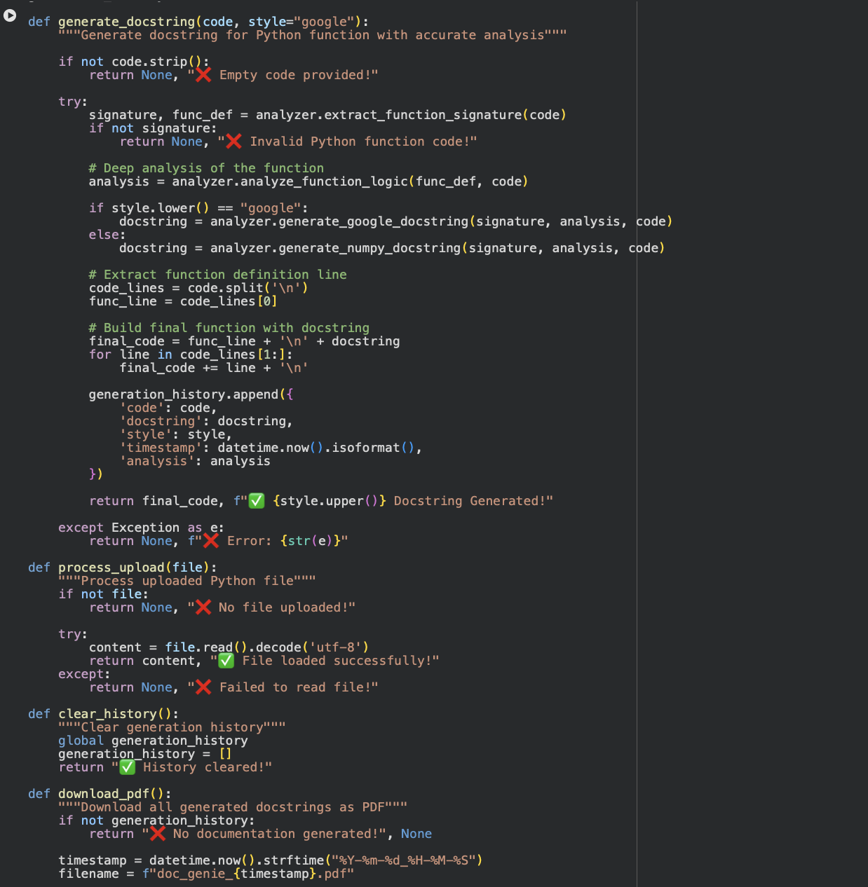Code reference
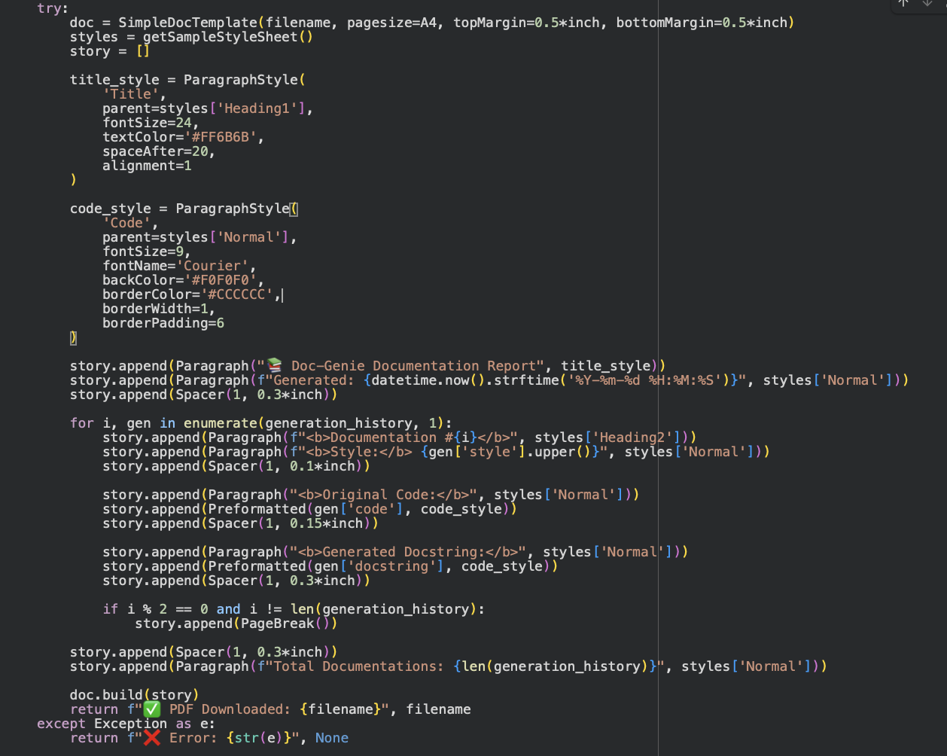Code reference
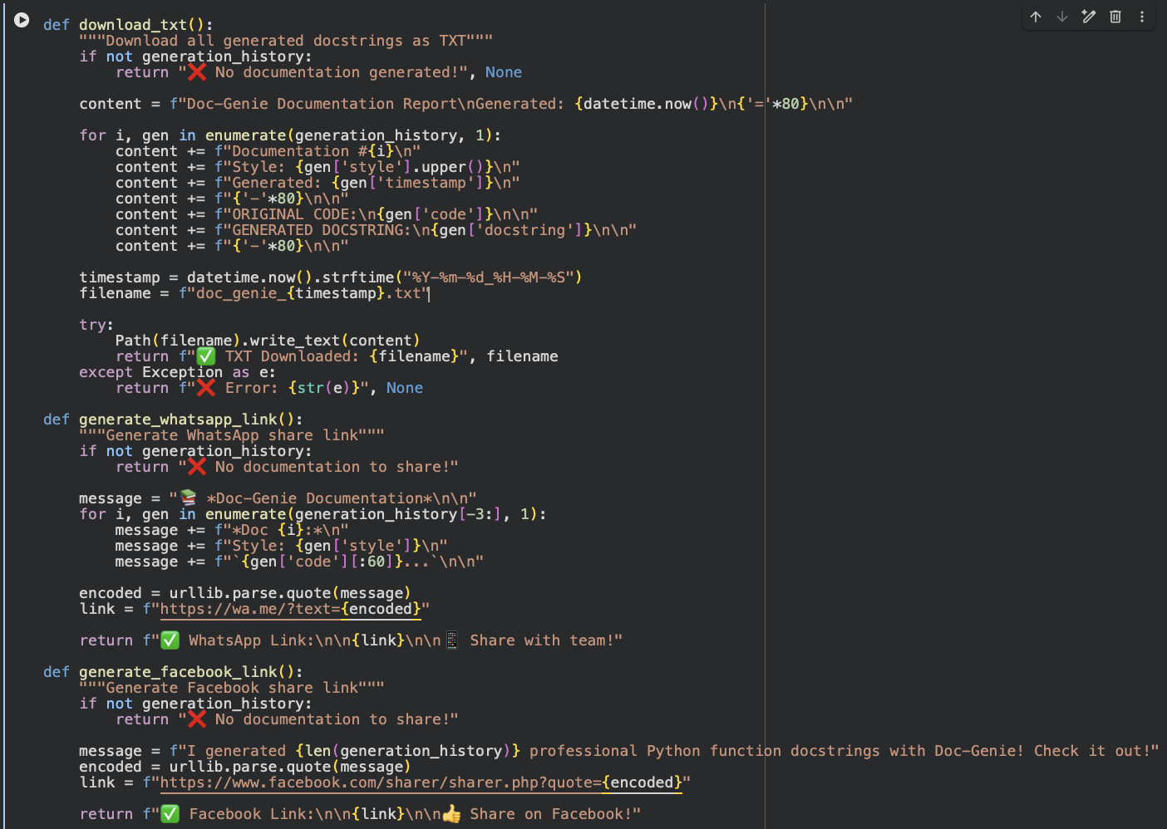Code reference

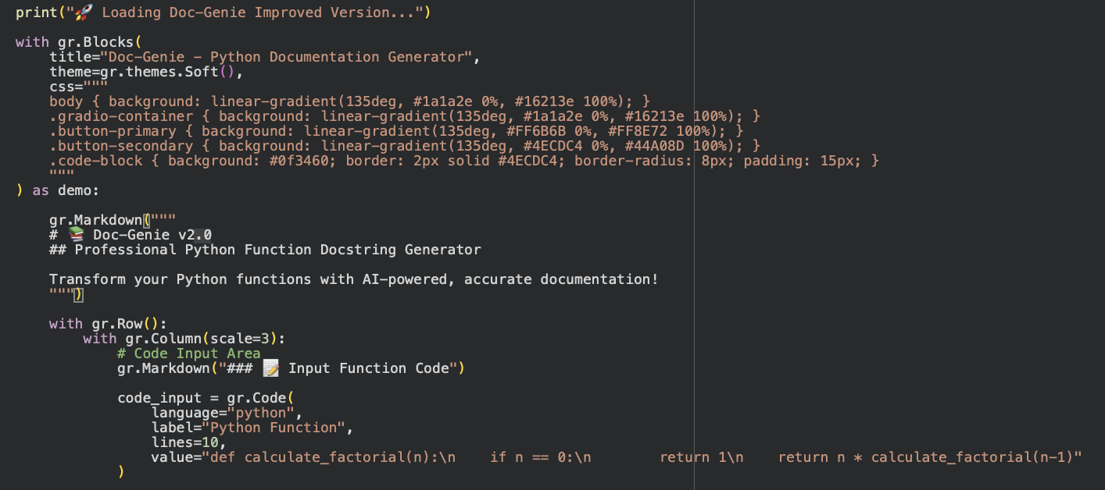Code reference

MILESTONE 4: Gradio Interface & User Experience

Interface Components Overview
The Doc-Genie system includes an interactive user interface built using the Gradio framework. The interface is designed to make the documentation generation process simple and user-friendly. Users can easily enter Python code, select documentation style, generate docstrings, and export the results.
The interface is divided into two main sections to improve usability.

Left Column – Code Input and Output
This section is used for entering and viewing Python code.
Main components include:
• Code Input Area – A text area where users can type or paste Python code. It supports multi-line input and syntax highlighting for better readability.
• File Upload Option – Users can upload Python files (.py) directly. The system reads the file content and displays it in the input area.
• Docstring Style Selector – Radio buttons allow users to choose between Google-style and NumPy-style documentation.
• Generate Button – After entering the code, the user clicks the generate button to start the documentation generation process.
• Output Display – The generated function with the docstring is displayed in a formatted code block that is ready to copy or export.

Right Column – Controls and Export Options
This section provides additional features for managing documentation results.
Main features include:
• Clear History Button – Allows users to clear previously generated results.
• PDF Download Button – Enables users to download the generated documentation as a PDF report.
• TXT Download Button – Exports documentation as a plain text file.
• Social Sharing Options – The system provides links to share documentation through platforms such as WhatsApp and Facebook.
These features improve usability and make the system convenient for developers and teams.

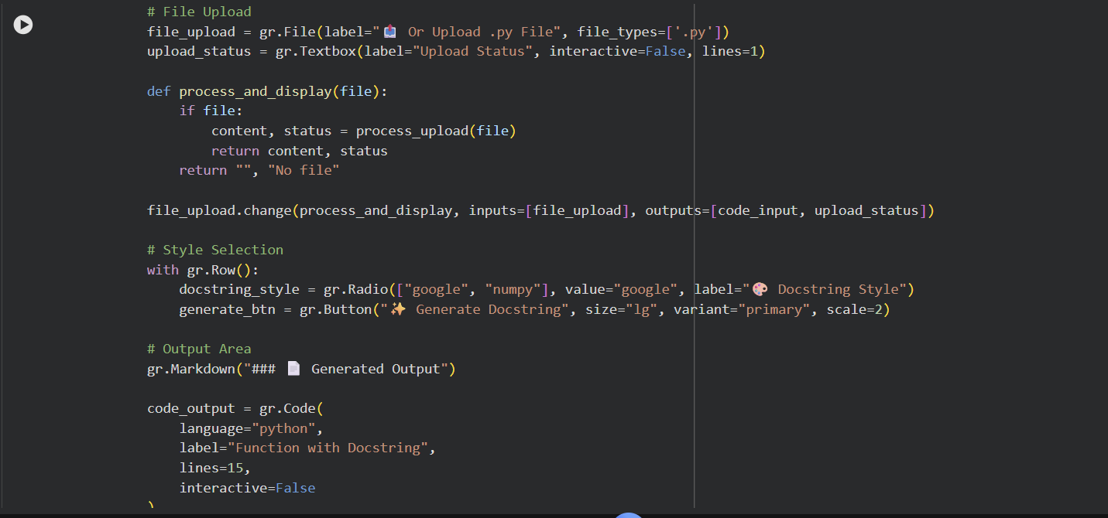Code reference
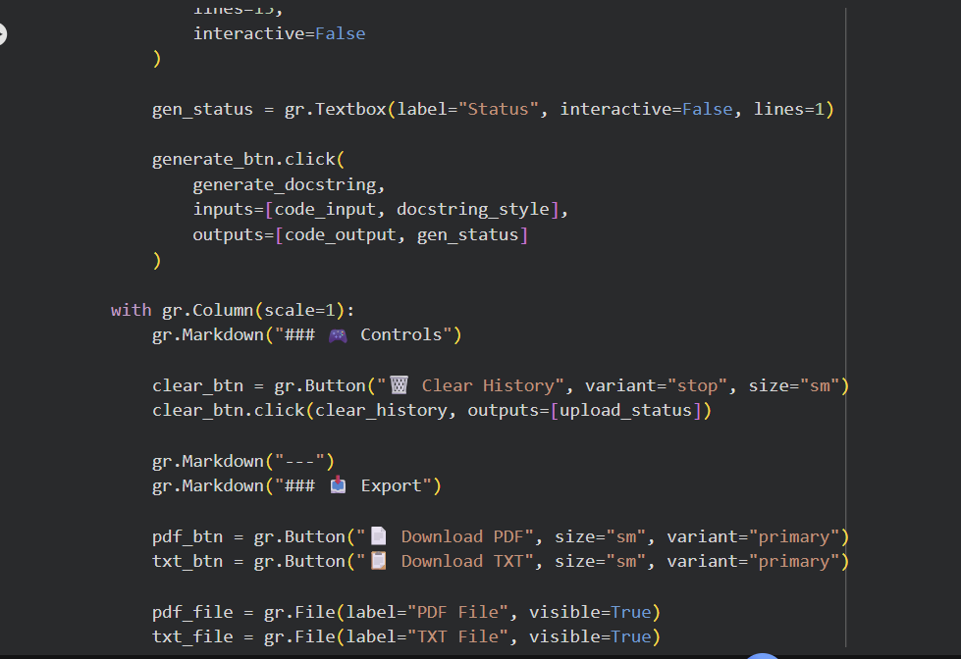
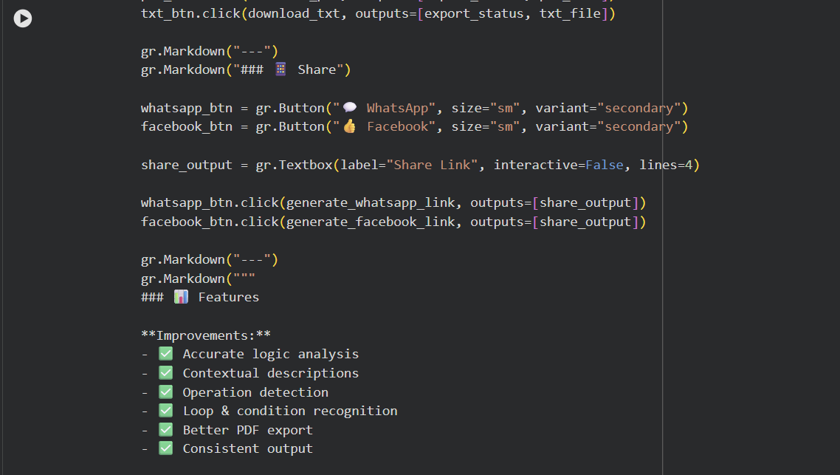Code reference

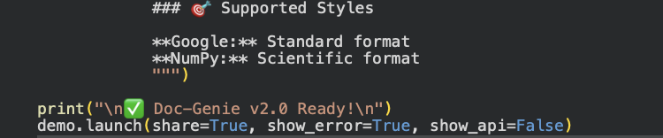Code reference

Activity 5.1: Google Colab Deployment
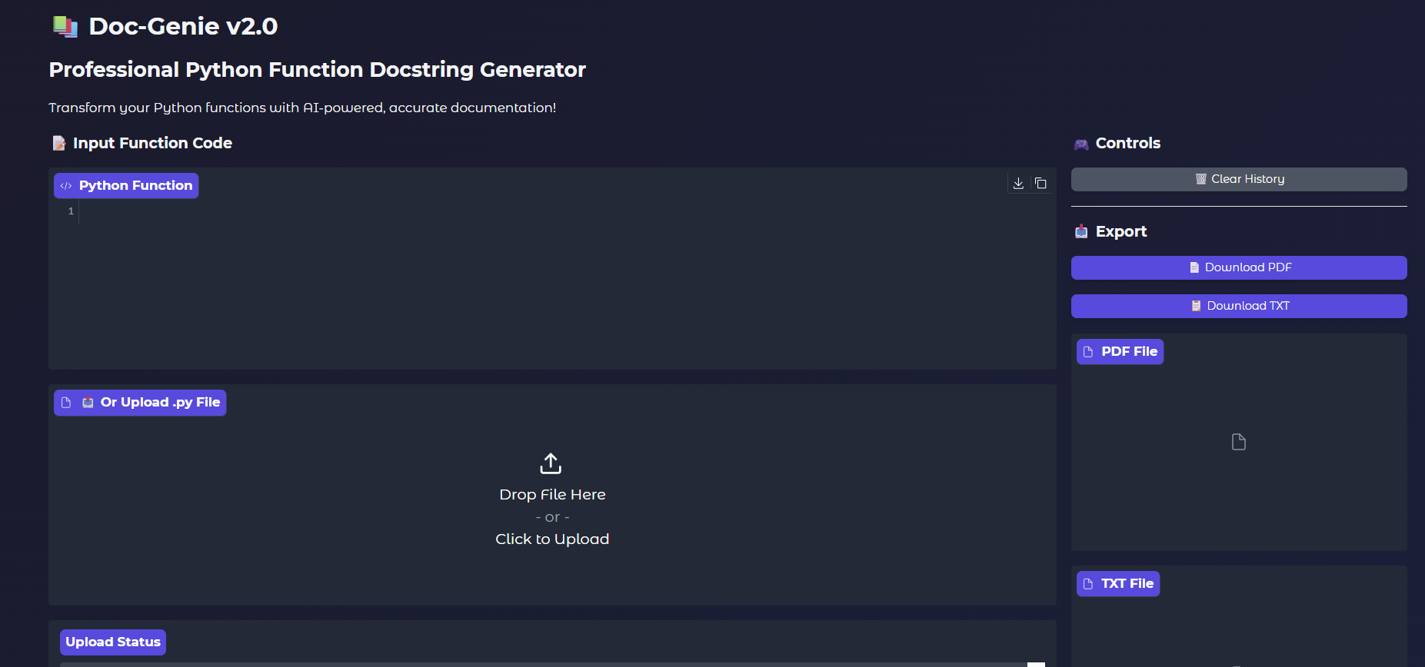

public URL: https://3ab3868bb13f172119.gradio.live

Activity 5.2: Functional Testing
After deployment, the system is tested to ensure that all features are working correctly. Functional testing verifies that the code analysis, documentation generation, and export features perform as expected.

Test Case Example
Input Code:
def calculate_factorial(n):
if n == 0:
return 1
return n * calculate_factorial(n-1)
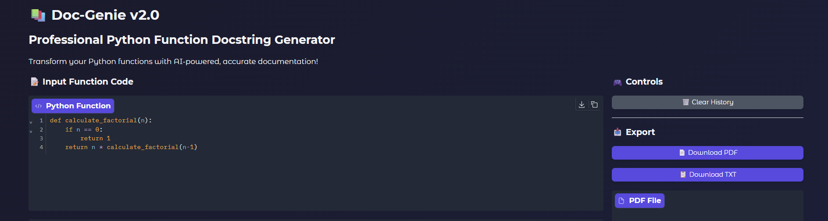
Expected Output:
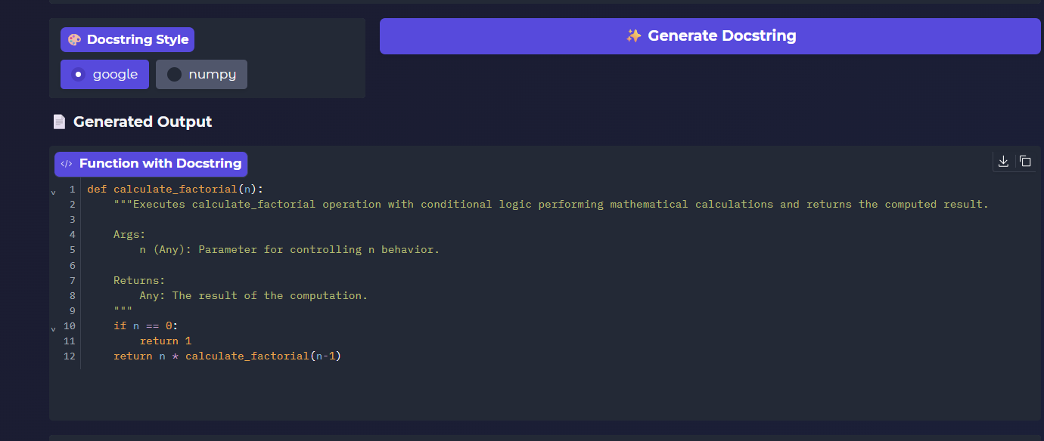
The system generates a correct docstring explaining the function parameters and return value.
Test Result:
✅ Successful docstring generation.
Testing confirms that the system accurately analyzes Python functions and generates correct documentation.

Future Enhancements
In the future, the Doc-Genie system can be improved by adding support for additional programming languages such as Java, C++, and JavaScript. This would allow developers working in different programming environments to automatically generate documentation for their code. The system could also be integrated with popular development tools such as Visual Studio Code and PyCharm, enabling developers to generate docstrings directly inside their coding environment without switching to another application.
Another possible enhancement is the integration of advanced artificial intelligence techniques to generate more detailed and context-aware documentation. The system could also be extended to support documentation for entire classes, modules, and larger codebases instead of only individual functions. Additionally, integrating the tool with platforms such as GitHub or GitLab would allow automatic documentation generation during code commits, helping development teams maintain consistent and up-to-date documentation across their projects.

Conclusion
Doc-Genie is an intelligent documentation generation system designed to simplify the process of writing Python function documentation. By using Python’s Abstract Syntax Tree (AST) module, the system analyzes the structure of Python code and automatically extracts important information such as function names, parameters, and return values. Based on this analysis, the system generates professional docstrings in standard formats like Google style and NumPy style, helping developers maintain clear and consistent documentation.
The integration of the Gradio interface makes the system easy to use, allowing users to input code, generate documentation instantly, and export the results in formats such as PDF and TXT. This project demonstrates how automated tools can reduce the effort required for manual documentation while improving code readability and maintainability. Overall, Doc-Genie provides an efficient solution for developers, students, and teams to generate high-quality documentation for their Python programs.

